SECTION NO. | SECTON NAME | MARK OBTAINED | MAXIMUM MARKS
I | Learning Process | 45 | 50
II | Final Examination | 42 | 50
 | TOTAL MARKS | 87 | 100

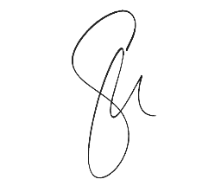
DATE – 5 JUNE 2025

SIGNATURE

